
DAYANAND SCIENE COLLEGE, LATUR

List of Inspire Scholarship for Higher Education(SHE) Qualified Students
Academic Year 2022-23
Sr. No. | Name of Student | Inspire Application  Reference Number | IVR No. | Result / Position | Photo | Contact No.
1 | DESHMUKH PAYAL SATISH | DST/INSPIRE/02/2022/026258 | 202200050229 | Sanctioned | 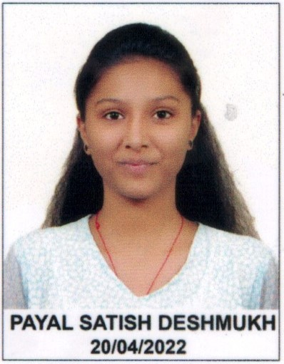 | 7972824655
2 | MUNDE SHREYA BALAJI | DST/INSPIRE/02/2022/018192 | 202200041120 | Sanctioned | 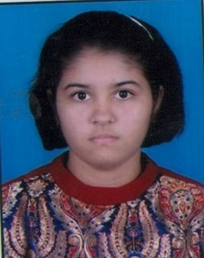 | 9766383279

IQAC Co-ordinator Principal

